Creating a Google Doc Using the iPad

- Log into your Gmail account and using the more tab select Docs.

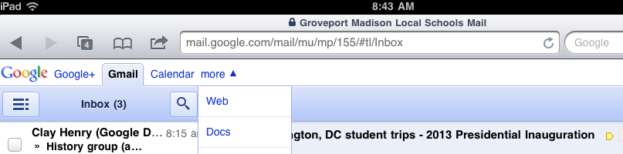
1

- Press the create icon and then select Document.
2

- Enter a title into the title box, and then press the Create icon to start a new document.
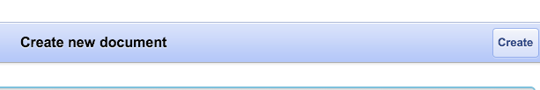
3

At this point you will add your text to the provided. The document will save automatically.

Sharing the Google Doc using the iPad

At this point the mobile application becomes tricky. You will first have to exit the document page. You will then have to re-access the Google docs page following step 1. Your recently created document is now shown in the list of documents on your main Docs page.

- Check the box next to the document you wish to share.
- The share box will now appear at the bottom of the list. Press this icon.
- Press the share option from the choices given.
- There should now be a copy of your document shown. To share, press the invite icon in the upper right hand corner.
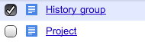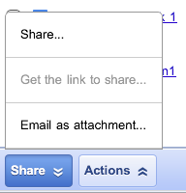
7
5
6
4

- Enter the email address for the person you wish to share the document with.
- Next, uncheck the “Notify people via email” box.
- Finally, press the “Share and Save” icon to share your document.

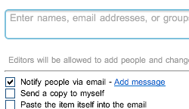
8
9
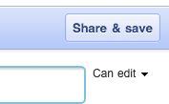
10

